Blueprint – Configuring a user’s VM Inbox Language

Background
This blueprint is a solution for idea AMUGM-I-76. This blueprint addresses the need to configure voicemail inbox language per user profile, rather than system-wide. This is particularly useful for environments with multilingual users, such as English and French speakers.
We can configure per user based on their division or if they have a primary number, we can do it by the international dialling code. This will only work if TTS is available for that language.

Step 1 – Create a data action
Create a Genesys Cloud Data Action: This action will retrieve the user's division based on their email. Ensure you have an active Genesys Cloud data actions integration with the appropriate permissions.
- Import the data action.
- Save & Publish the data action.

Step 2 – Inbound call flow
In this case I have named my inbound call flow SetVoicemailLanguage.
You can import the Inbound Call Flow below.
Create your own Inbound Call Flow by following the steps below.
In your inbound call flow create a reusable task and give it a name.
Add an Update Data Block, you will need to add 3 string statements.

Variable Name | Value to Assign
Flow.language | e.g. en-gb (default language)
Flow.UserSIP | If(ToPhoneNumber(Call.Ani).isSip,Call.Ani,"")
Flow.CallerNumber | If(ToPhoneNumber(Call.Ani).isTel,ToPhoneNumber(Call.Ani).e164,"")

- The first is Flow.language this is for setting a default language to use if there is no specific language set for that division/international dialing code.
- The second Flow.UserSIP is to check if the Call.Ani is a sip address, we will manipulate this later to return the users email.
- The third Flow.CallerNumber is to check whether the Call.Ani is a telephone number and to return the number in e164 format if it is.
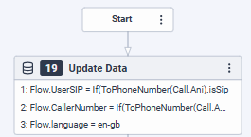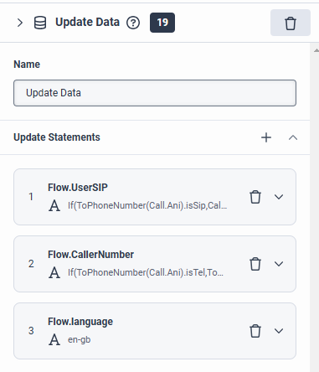

Add a Decision Block with the following

Decision
IsNotSetOrEmpty(Flow.CallerNumber)

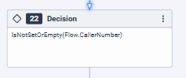

Nothing is required under the No path

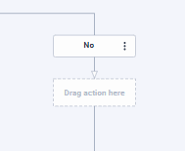

Under the Yes path add an Update Data Block and add 3 string statements.
Here we manipulate the Flow.UserSIP to convert it to the users email address.

Variable Name | Value to Assign
Flow.UserEmail | Left(Flow.UserSIP,Length(Flow.UserSIP)-10)
Flow.UserEmail | Right(Flow.UserEmail,Length(Flow.UserEmail)-4)
Flow.UserEmail | Replace(Flow.UserEmail,"%40","@")

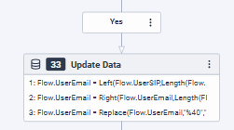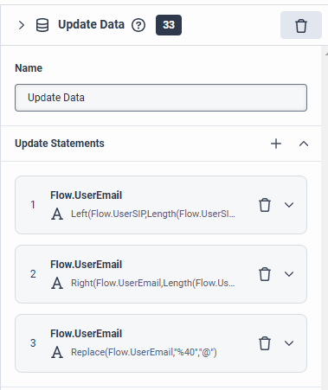

Still under the Yes path, add a Call Data Action.
Select the category that the “Get Users Division From Email” is under in this case it is Genesys Cloud Data Actions.
Data Action - “Get Users Division From Email”.

Inputs for the Data Action | Value to Assign
email | Flow.UserEmail

Success Outputs | Value to Assign
results__division__name | Flow.Division
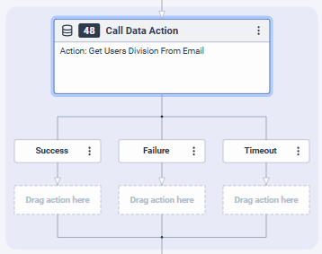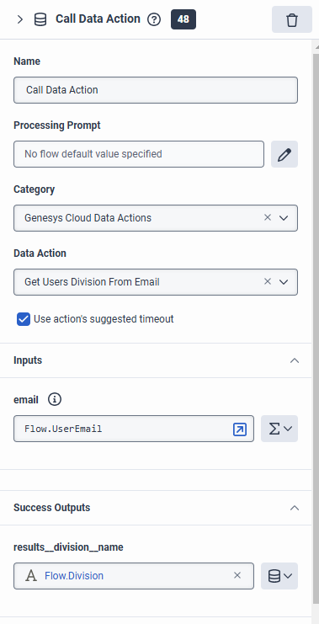

Outside of the decision block, you can add a switch block for determining which language is to be used in the users voicemail inbox either based on their international dialling code or the users division.

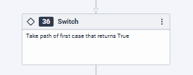

In the cases you can include the following
Case | Value to Assign
1 | If(IsNotSetOrEmpty(Flow.Division),false,Contains(Flow.Division,"Input division name here")) or If(IsNotSetOrEmpty(Flow.CallerNumber),false,ToPhoneNumber(Call.Ani).dialingCode == "input international dialling code here")
2 | If(IsNotSetOrEmpty(Flow.Division),false,Contains(Flow.Division,"Input division name here")) or If(IsNotSetOrEmpty(Flow.CallerNumber),false,ToPhoneNumber(Call.Ani).dialingCode == "input international dialling code here")
3 | If(IsNotSetOrEmpty(Flow.Division),false,Contains(Flow.Division,"Input division name here")) or If(IsNotSetOrEmpty(Flow.CallerNumber),false,ToPhoneNumber(Call.Ani).dialingCode == "input international dialling code here")

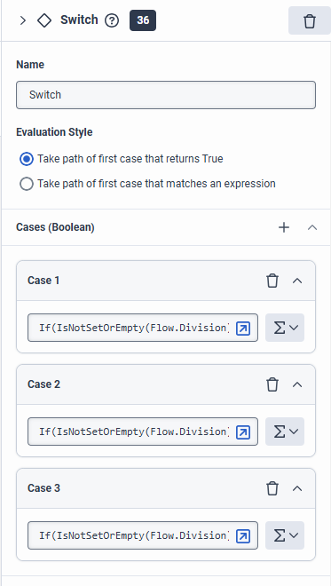
Under each case you will add an Update Data Block, you will add a string statement to update the Flow.language with the appropriate language required

Variable Name | Value to Assign
Flow.language | e.g. en-gb

You can repeat this until you have included all required languages. You can leave the default path blank as you have set the default language at the start of the flow
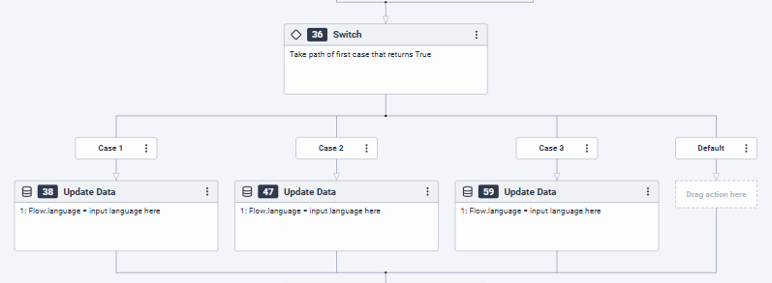

Outside of the switch, you will add a Transfer to Number Block.
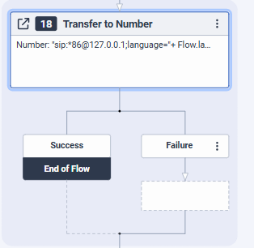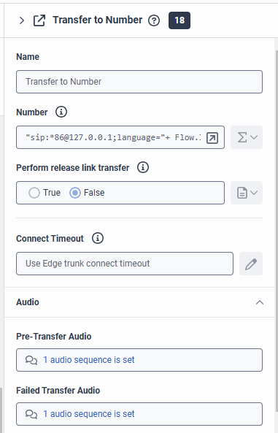

In the number input, input the following - "sip:*86@127.0.0.1;language="+ Flow.language + ";user=voicemailbox"

Add a Disconnect Block at the end of the inbound call flow.
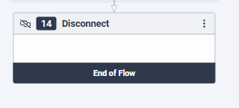

Publish the flow.

Step 3 – Configuring the site
Here you will configure your site to push all users that dial *86 into your inbound call flow that you created.
In your Site, click on Number Plans.
Click on + New Number Plan
Number Plan name - VM.
Match Type - Regular Expression.
Match Expression - ^\*86$
Normalized Number Expression will be the name of your inbound call flow, I have named my inbound call flow SetVoicemailLanguage - sip:SetVoicemailLanguage@localhost
Classification - VM.
Click Save Number Plans
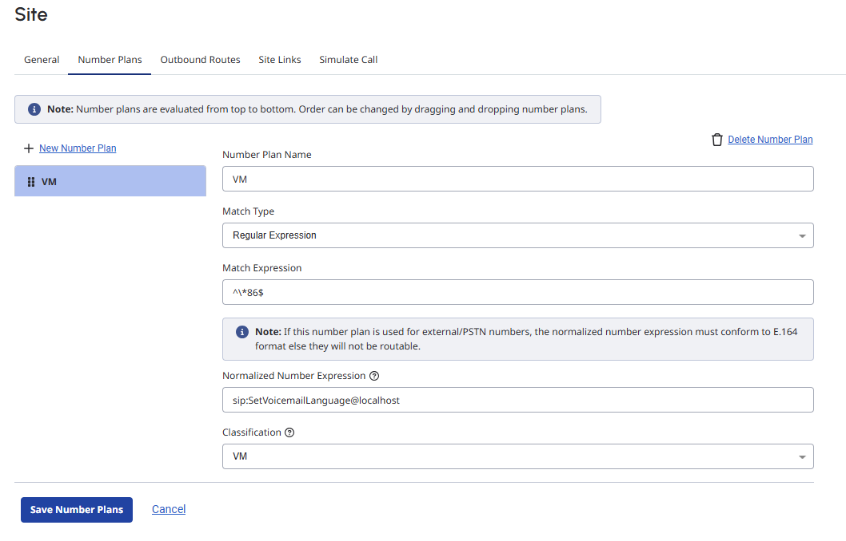
Make a test call from your phone to *86 to make sure the language that you configured is being used.

